Endurance Bamboo
Bamboofloorin@isgn attracti e alternative to hardwoodfloors.
Naturally self-generating, "bam oo grows to maturity withinfiveyears and is regarded as the strongest

plant on earth. nPDECK FLOORING
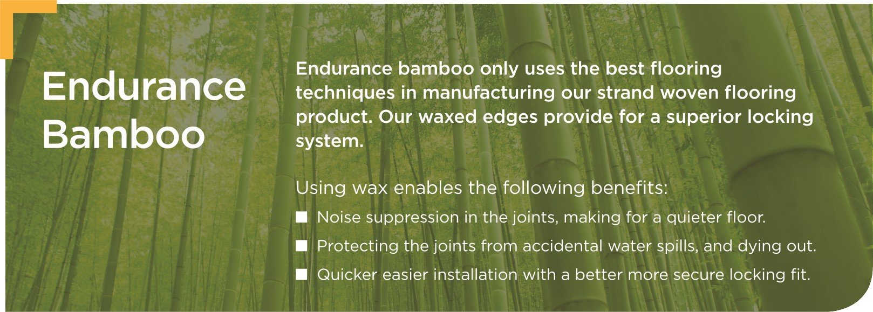

Endurance Bamboo Solid Collection
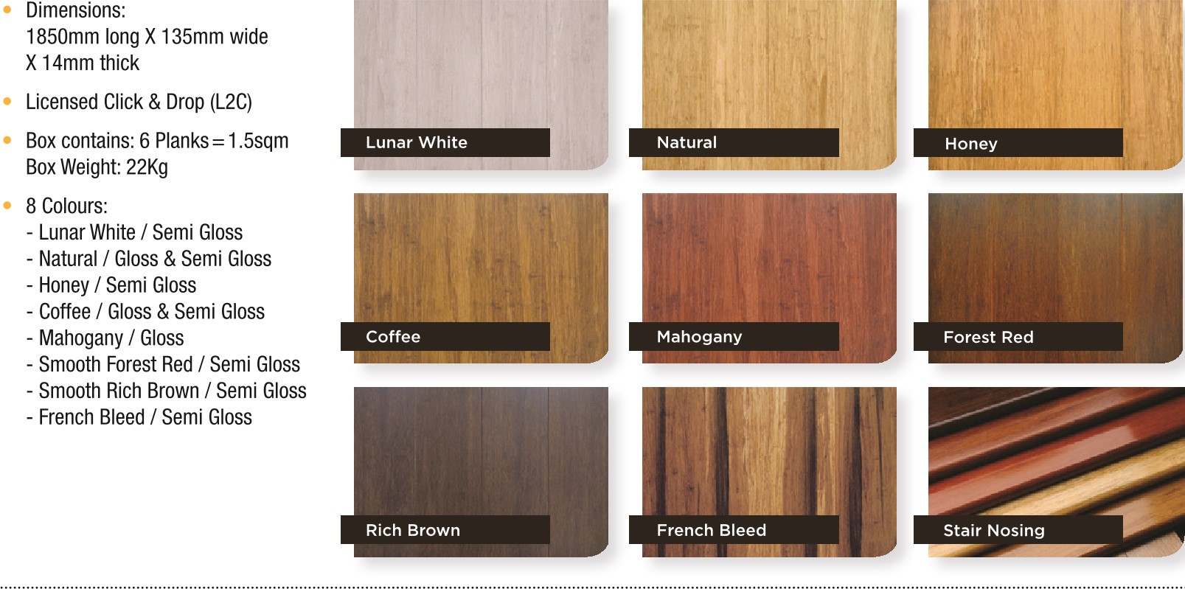
Endurance Bamboo Engineered Collection
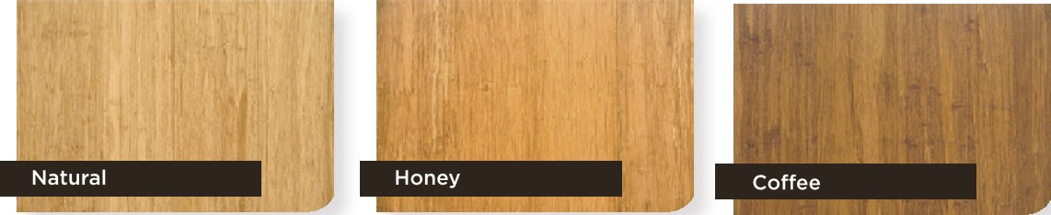
Dimensions:
1830mm long X 190mm wide
X 3/14mm thick
Semi Gloss Finish
- Box Contains: 6 Planks = 2.0862sqm
Box Weight: 22Kg
- 5G Licensed Lock System
Rich Brown | 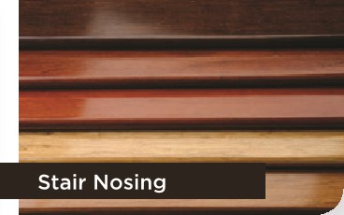
Proud to be a Member of the
atta
aSSOCiMian

ENDURANCE BAMBOO SOLID COLLECTION ENDURANCE BAMBOO ENGINEERED COLLECTION TECHNICAL SPECIFICATIONS
59

INSTALLATION METHOD
Floating Floor

COATING FINISH
9 layers of Treffert water-based polyurethane finish
HARDNESS
Janka 15kn

COLOUR COLLECTION
Lunar White, Natural, Honey Coffee, Mahogany, Forest Red, Rich Brown, French Bleed

FIRE RATING
Critical Heat Flux & Critical Radiant Flux (CHF &
Combining quality & environmental control standards throughout the manufacturing process.
International
Organization for
Standardization
FSC
As bamboo is a natural product, the colour, grain and feature patterns will vary in the flooring as in the printed media.
For detail maintenance & installation guidelines please refer to the website.
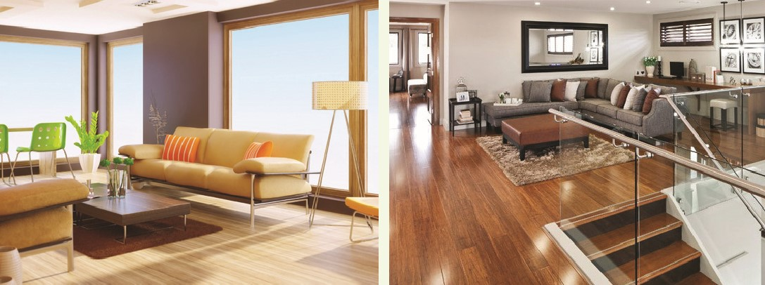
CRF) 4.9kw/m ²

SLIP RATING
Slip Resistance Value (SRV): 15 (PI) as per Slip Resistance AS 4586 (2013)
ENVIRONMENTAL & QUALITY

CERTIFICATES
VOC EO (0.2Mg/L) Tested in accordance to
IS016000 parts -3 -6 -9 -11 standard
IS09000 Quality control System and IS014000 Environment Control System, CE and FSC certificate

STRUCTURAL WARRANTY
25 years residential 10 years commercial
COATING WARRANTY
5 years residential 3 years commercial

